Learning Institutions Convergence into e-Learning 2.0 via Web 2.0 Technologies
A. M. Riad (1), Hamdy K. El-Minir (2), Haitham A. El-Ghareeb (3)
(1) Head of Information Systems Department, Faculty of Computers and Information Sciences, Mansoura University, Egypt
amriad2000@mans.edu.eg
(2) Head of Communication Department, Misr Higher Institute of Technology and Engineering, Mansoura, Egypt
hamdy_elminir2@yahoo.com
(3) Information Systems Department, Faculty of Computers and Information Sciences, Mansoura University, Egypt
helghareeb@mans.edu.eg
Abstract: Several types of Information and Communication Technology "ICT" have been utilized in the learning process to overcome time and place challenges. The widespread of web 2.0 resulted in the appearance of e-Learning 2.0. Web 2.0 changed the way everyone thinks about and accesses the internet and will touch the coming generations. This paper presents taxonomy of web 2.0 technologies, highlighting how and when they can be used within learning institutions for enhancing the learning process. Web 2.0 technologies can be classified into in-lecture and after-lecture technologies. This paper highlights different studies that show the importance and need by both instructors and students to utilize web 2.0 technologies, presents different ways to use them, highlights the importance of Service Oriented Architecture (SOA) in adopting Web 2.0 technologies in current lecture model, and concludes with future research directions on e-Learning 3.0.

Keywords: e-Learning, e-Learning 2.0, e-Learning 3.0, Service Oriented Architecture (SOA), Enterprise Architecture
تحول مؤسسات التعليم إلي التعليم الإلكتروني 2.0 عبر تقنيات الويب 2.0
الخلاصة: استخدمت عدة أنواع من تكنولوجيا المعلومات والاتصالات في عملية التعليم للتغلب على تحديات الزمان والمكان. وأدى اتساع نطاق شبكة الإنترنت 2.0 إلى ظهور التعليم الإلكتروني 2.0. ساعد الويب 2.0 على تغيير طريقة استخدام الانترنت وسوف تلمس الأجيال القادمة هذا التغيير. يقدم هذا البحث تصنيف تقنيات الويب 2.0 ، وإبراز كيف ومتى يمكن استخدامها داخل المؤسسات التعليمية لتعزيز عملية التعليم. ويمكن تصنيف تقنيات الويب 2.0 إلى: تقنيات في المحاضرة في وتقنيات بعد انتهاء المحاضرة. هذا البحث يسلط الضوء على مختلف الدراسات التي توضح أهمية وضرورة كل من تكامل و تفهم المعلمين والطلاب للاستفادة من تقنيات الويب 2.0 ، ويعرض طرق مختلفة لاستخدامها ، ويسلط الضوء على أهمية الهيكل خدمي التوجه في اعتماد تقنيات الويب 2.0 لتندرج ضمن النموذج الحالي للمحاضرة ، و يختتم البحث باستعراض اتجاهات البحث العلمي المستقبلي في التعليم الإلكتروني 3.0.

List of acronyms and abbreviations
- CMS: Course Management System
- ICT: Information and Communication Technology
- IMS (a.k.a ITIMS or IMS GLC): a global, nonprofit, member organization that strives to enable the growth and impact of learning technology in the education and corporate learning sectors worldwide.
- IMS QTI: IMS - Question and Test Interoperability
- LMS: Learning Management System
- RSS: Really Simple Syndication
- SIS: Student Information System
- SOA: Service Oriented Architecture
- UMIS: University Management Information System

- Introduction
Using ICT in learning has a long history and was handled in different ways and from different points of views over the years. Though most of the time this diversity has led to the most inappropriate understandings and misleading implementations of the concepts, it has also opened the way for different approaches that has been under validation and evaluation over the years. The learning institution in concern for this paper is the University. The focus of this section will be on information systems that were presented over the years to facilitate university activities. Then, the attempts of different learning institutions to utilize web 2.0 technologies will be presented. Current widely spread technologies in learning institutions include utilizing ICT in the learning process mainly for two categories: University Management Information Systems (UMISs), and Learning Management Systems (LMSs). El-Ghareeb (2009) compares systems’ components, scopes, interest, usage, features, and utilization in universities yielding that [1]:
- UMIS: used in handling and managing managerial aspects of the university. They have almost nothing to do with the pedagogical process. However, their existence is almost a must. UMIS exceeds LMS by decades and has reached stable levels of well-defined requirements, existence, acceptance, implementation and performance levels. UMIS include different sub information systems that work to facilitate and manage the activities of different parts of the university as an organization. Examples of those sub information systems are: Student Information System (SIS), Library Information System, Faculty Information System and Finance System.
- LMS: used in handling and managing the learning process. LMS implements technologies that enable virtual/digital university and/or personal learning environments. LMS features can be categorized into four sub systems concerned with courses, exams, assessments and collaborative features. LMS can be thought of as the integration of these four sub systems. Each one presents specific functionalities via specific tools. Providing online lectures via videoconferencing and recording capabilities used to be optional in LMSs.

Both UMIS and LMS have to integrate and operate together to support educational institutions and e-Learning. One of the international initiatives that provide information to institutions on investing in and using information technology infrastructure is e-Framework “http://www.e-framework.org”. The e-Framework for education and research has been established to help the education and research arenas take advantage of the opportunities offered by the service-oriented approach. The primary goal of the e-Framework is to facilitate technical interoperability within and across education and research through improved strategic planning and implementation processes. The e-Framework is a collaborative effort that recognizes greater coherence in development is needed and thus aims to provide an overview of current development and experiences in services-oriented approaches.

This paper goes as follows: section 2 presents web 2.0 technologies, examples of current available technologies, statistics about their utilization, and how they changed the internet perception for users. Section 3 highlights the transition from e-Learning to e-Learning 2.0 via utilizing different web 2.0 technologies. Section 4 reviews evaluation of web 2.0 utilization in learning institutions from theory and practice. Section 5 presents real world examples of utilizing web 2.0 technologies in learning institutions and summarizes a comparison between them. Section 6 presents taxonomy of web 2.0 technologies that can be used in learning institutions, highlighting its different classes and components. Section 7 takes a closer look on the future of attended classes based on presented facts and highlighted trends. Section 8 presents future research directions for comprehensive utilizing of web 2.0 technologies and a look on technologies that transitions e-Learning into e-Learning 3.0. Section 9 concludes the paper.

- Web 2.0 Technologies
Ever since group behavior became an important part of mainstream websites, companies have found numerous ways to exploit the behavior of web surfers. Simple uses of web 2.0 ideas include businesses like amazon.com soliciting product rankings from consumers and offering shoppers hints of what others have bought. Moreover, notions of web 2.0 include the many social networking web sites that have tried to profit from the basic human need to connect with others. Facebook, MySpace, Friendster, Tribe, LinkedIn, Spoke, and countless others have looked to profit on connecting teens, communities, professionals and just about any other type of demographic. The web 2.0 phenomenon is more rightly described as a social and behavioral sea change. Instead of serving up static fixed content to web surfers, the web has become an interactive place for people to congregate and do things together virtually. Web 2.0 is about the way people use web 1.0, not about the web itself [2]. Web 2.0 refers to the social use of the web which allows people to collaborate, to get actively involved in creating content to generate knowledge and to share information online [3].

Most instructors are interested in utilizing whatever their hands reach to in enhancing and supporting the learning process. Instructors are surrounded by acronyms that are completely new to them, and there is not enough time to get used to one of the technologies before another becomes available. Figure 1 highlights instructors’ distraction between different acronyms that are made available and easy for students to utilize and are under study by e-Learning researchers. All those technologies are available, but there are always some questions that need answers: How to utilize them? What are the efficiencies and drawbacks on the learning process and on learners from utilizing them? And are those technologies convenient with the learning institutions’ policy?
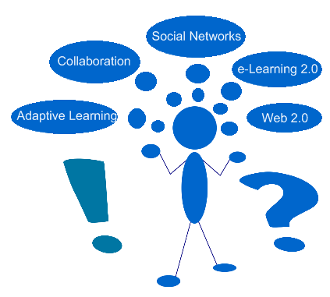
Figure 1: Instructor Challenges between Students and Researchers
Figure 2 presents a collection of different Web 2.0 implemented technologies that can be utilized in e-Learning 2.0. Presented list is not meant to include all presented examples because they are plenty and the list is updated every day. However, it is meant to include the most accepted and highly deployed implementations of web 2.0 technologies. Those examples gained a huge acceptance and access from online users. This paper does not tend to present a full coverage and/or a list of highlighted web sites’ users. The following numbers are just for proof of concept. Table 1 presents some facts about web 2.0 online usage statistics based on Google Ad Planner statistics on November 9, 2009. All statistics are in approximate.

Figure 2: e-Learning 2.0 Supportive Technologies Online Implementations
Table 1: Some Facts (Statistics) about Most Popular Web 2.0 Sites Usage Statistics
 | Cookies | Visitors | Reach | Page Views | Total Visits | Avg. Visits | Avg. Time
Twitter | 120 M | 66 M | 5.2 % | 4.4 B | 600 M | 9 | 12:10
Facebook | 710 M | 410 M | 32 % | 220 B | 10 B | 25 | 23:20
MySpace | 190 M | 99 M | 7.6 % | 29 B | 1.1 B | 12 | 21:40
WikiSpaces | 3.8 M | 2.2 M | 0.2 % | 50 M | 6.7 M | 3.1 | 8:10
LinkedIn | 67 M | 35 M | 2.7 % | 1.7 B | 190 M | 5.5 | 9:50
Blogger | 66 M | 42 M | 3.2 % | 1.7 B | 210 M | 5 | 10:50
MindMeister | 290 K | 170 K | 0 % | 3.8 M | 760 K | 4.6 | 10:40
LiveStream | 1.4 M | 740 K | 0.1 % | 15 M | 2.9 M | 3.9 | 12:00
Flickr | 120 M | 65 M | 5.1 % | 3 B | 250 M | 3.8 | 9:00
Zoho | 1.5 M | 830 K | 0.1 % | 51 M | 5.6 M | 6.8 | 15:50
SlideShare | 16 M | 9.1 M | 0.7 % | 66 M | 21 M | 2.4 | 6:00

Google Ad Planner is a free media planning tool that can help identify websites where audience is likely to visit. Table 1 Columns details are:
- Cookies: approximate number of cookies on a site over a specific month.
- Visitors: estimated, unduplicated number of people who visit a site over a month.
- Reach: total estimated number of users you can reach on a specific site.
- Page Views: total estimated number of times pages on a site have been accessed.
- Total Visits: estimated number of times a site is accessed by unique visitors.
- Average Visits Per Visitor: estimated number of times a unique visitor accesses a site over a specific month.
- Average Time on Site: estimated average amount of time, in seconds, that a unique visitor spends on a site.

Total number of users and visits mentioned in table 1 exceeds billions. What really matters most is the Growth Rate of web 2.0 sites. Twitter for example is a phenomenon that shall be closely studied and made use of in different aspects of twitters users’ lives. In December 2008, 11% of online adults said they used Twitter or another service to update their status online [4]. In April 2009 study showed that the percent had increased to 19% of internet users [5]. Table 2 presents a new survey from Nielsen about the five fastest growing "member community destinations" in the U.S.

Table 2: Survey from Nielsen about the five fastest growing "member destinations" in the U.S
RANK | Site | Feb 08 | Feb 09 | % Growth
1 | Twitter.com | 475,000 | 7,038,000 | 1382%
2 | Zimbio | 809,000 | 2,752,000 | 240%
3 | Facebook | 20,043,000 | 65,704,000 | 228%
4 | Multiply | 821,000 | 2,394,000 | 192%
5 | Wikia | 1,381,000 | 3,758,000 | 172%
Source: Nielsen Net View, 2/09, U.S., Home and Work
http://blog.nielsen.com/nielsenwire/online_mobile/twitters-tweet-smell-of-success/
Table 3 presents a comparison between the top rated technology tools used in conjunction with education from students’ perspective, and the same tools utilization in teaching from instructors’ perspective based on data from the 2009 21st Century Campus Report [6]. There is a huge gap that hopefully will be addressed by different web 2.9 utilization models. Though both use web 2.0 technologies outside the class, instructors and students still rely on traditional methods to communicate with each other.

Table 3: Percentages of Technology tools conjunction with education/teaching by Students / Instructors based on The 2009 21-st Century Campus Report (2009)
 | Students | Instructors
Social Networking Sites | 52% | 14%
Web Applications | 31% | 12%
iPod / MP3 player | 31% | 8%
Wikis | 28% | 11%

- Transition from e-Learning to e-Learning 2.0 via Web 2.0 Technologies
The web 2.0 effect on e-Learning is transitioning it into e-Learning 2.0. e-Learning witnesses now the middle era that is characterized by the presence of “informal learning”, and that is preparing it for e-Learning 3.0. e-Learning 3.0 is characterized by utilization of semantic web or what is called web 3.0 and 3D virtualization that will play a significant role in this transition in the near future as depicted in figure 3. A closer look on e-Learning 3.0 will be presented in future research directions section of this paper.
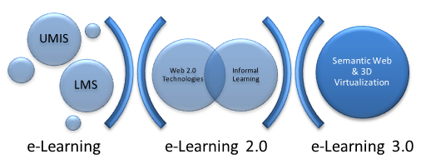
Figure 3: e-Learning Transitions From e-Learning to e-Learning 3.0 via e-Learning 2.0
While the focus in e-Learning was on presenting information systems that manages the abovementioned activities and tasks in section 1, the change in the internet that is enabled by web 2.0 technologies reflected directly on the learning process. e-Learning 2.0 presents opportunities for instructors to utilize new technologies and overcome challenges and limitations of current learning process, get students in the middle of the learning process, embed technologies that todays’ students live within the learning process hopefully reaching a life-long learning model that seamlessly integrates with students’ lives. It has been remarkably noticed there are boundaries between what students utilize during learning and what they utilize during “spending time” on the internet. e-Learning 2.0 tends to enhance the learning process, make use of “informal learning” opportunity, and present a model of “life-long learning” via a bulkhead removal. Figure 4 shows the transition from e-Learning to e-Learning 2.0 in information sources. In e-Learning, the instructor was the main source of information for students. He/she was responsible for preparing the learning materials, defining learning plan and other learning activities. Though this fact still applies to e-Learning 2.0, instructors shall not ignore the fact that students have different sources of information. Figure 5 highlights the transition from e-Learning into e-Learning 2.0 by presenting a new informal feedback method. Students might feel more comfortable in responding to instructors and communicating over informal feedback channels more than they do in the formal feedback environment. Instructors can make use of this comfort in conducting informal assessments that help instructors get a closer look and feel of their students. Figure 6 presents one of the transition forms from e-Learning into e-Learning 2.0 from flow of information transition. Students in e-Learning 2.0 play an important role in updating information, not just receiving it. They can participate in updating learning materials based on their perception and understanding of learning topics.

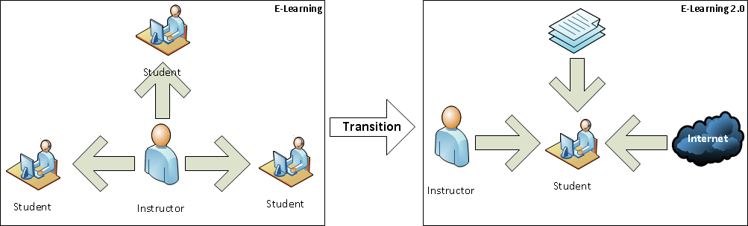
Figure 4: Transition from e-Learning to e-Learning 2.0 in Information Sources
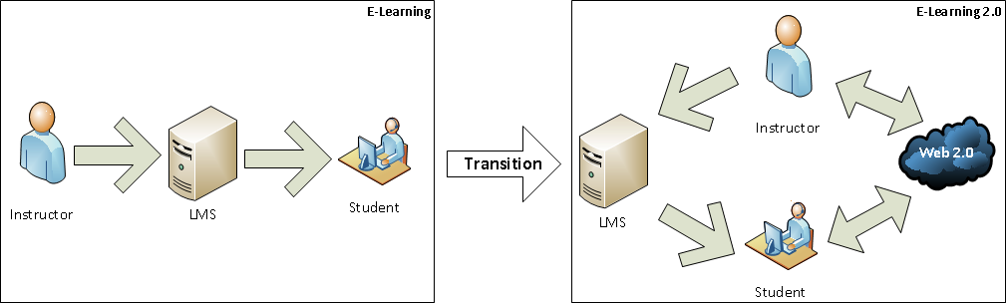
Figure 5: Transition from e-Learning to e-Learning 2.0 in Feedback
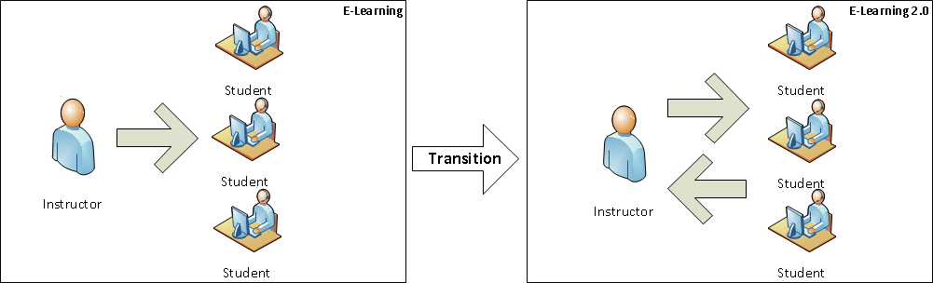
Figure 6: Transition from e-Learning to e-Learning 2.0 in Information Flow

- Web 2.0 Utilization in Learning Institutions between Theory, Practice, and Evaluation
Web 2.0 research in e-Learning is a research point of interest. Collaboration, semantic web, ontologies, Web services, SOA and many other technologies have been presented, utilized and evaluated within the learning domain. This section presents different research papers, implementation practices and case studies of adopting web 2.0 technologies in learning institutions. Web 2.0 platforms are seen to have an emerging role to transform teaching and learning [7]. One of the research papers that address different scenarios for utilizing web 2.0 technologies in e-Learning is the one presented in [3]. Some possibilities and examples of using web 2.0 technologies as a support for preparing and collecting didactic materials, evaluating and analyzing the progress made by students, putting together informative and formative presentations, time management, planning the timetable and the calendar of activities, developing projects in collaboration, digital storytelling, students’ e-portfolios, and others were rendered. Rendered web 2.0 technologies include: blogging, micro blogging, wikis, photo/slides sharing, video sharing, syndication of content through RSS, social bookmarking, social networking, and other tools. Advantages and challenges of utilizing web 2.0 technologies in the learning process, and the need to invent pedagogy 2.0 that goes a long with e-Learning 2.0 enabled by web 2.0 technologies’ utilization in the learning process were addressed.
One of the available online guides for implementing web 2.0 in e-Learning is the one presented by Downes [8]. This article presents ten things to do via different technologies to make the maximum benefits out of web 2.0. Learning activities include: podcasting, video casting, blogging, slide sharing, Goggling, and commenting on others' posts and activities, socializing via facebook, and other activities.

The three main players in the learning process need to co-operate to adopt and implement web 2.0 technologies in the learning process. They are: learning institution’s management, instructor, and student. Learning institution’s management presented by Chief Information Officers (CIOs) give high priority for advanced learning features provided by new technology trends. Agee et al. state that teaching and learning with technology is ranked #5 this year, moving up from #9 in the 2008 survey as the top priority of CIOs [9]. CIOs have become crucial to instructional units because they provide leadership in evaluating and supporting the teaching technologies that underlie multiple forms of distributed learning. A growing proportion of learning takes place outside the traditional boundaries of the classroom facilitated by applications such as social networks and technologies that support a culture in which everyone creates and shares. CIOs are being asked to provide technological directions for cultural transformations such as information fluency that involve library faculty, department faculty, technology specialists and students as co-creators of knowledge. Finding the proper balance between systemic and ad hoc technologies will be fundamental for IT leaders as they respond to a student generation that prefers less passive and more agile learning. These instructional modalities will foster transformational innovations such as the need for e-portfolios in a reflective, contextual, authentic and active learning environment.

On the other hand, Ajjan and Hartshorne assess faculty’s staff members’ awareness of the benefits of web 2.0 to supplement in class learning and better understand of faculty’s decisions to adopt these tools. Findings indicated that while some faculty members feel that some web 2.0 technologies could improve student’s learning, their interaction with faculty and with other peers, their writing abilities and their satisfaction with the course; few choose to use them in the classroom [10]. Additional results indicated that faculty’s attitude and their perceived behavioral control are strong indicators of their intention to use web 2.0. The results highlight that while a somewhat considerable proportion of the faculty felt that selected web 2.0 technologies would likely provide their students with many benefits, only few chose to use it. The lack of experience with most web 2.0 technologies examined in this study could drive faculty members to avoid their adoption although they realize that this adoption would provide their students with many important benefits.

Küfi and Özgür present an elaboration on the effectiveness of the most recent web based tools from the student perspective [11]. The present study aimed to develop a comprehensive insight into two hundred freshman students’ perceptions regarding the use of an interactive web environment in English communication courses offered by the department of General Education at Eastern Mediterranean University. Utilized web 2.0 technologies include: wiki and moodle. Though utilized technologies are really so simple, they achieved the required objectives and provided students with the suitable environment to create their own interactive web environment for their classes. The analysis of data shows that the majority of students is positive about the use of an interactive web environment and finds its use beneficial for their learning. Based on the research results, 50% of students enjoyed learning English by using wiki/moodle, and 52.5% of them agree that the interactive web environment created for English course helped them to improve their English.

- Real World Examples of Utilizing Web 2.0 Technologies in Learning Institutions
Utilizing web 2.0 technologies in learning institutions is a hot topic and a brand new field that depends mainly on each learning institution’s capabilities, infrastructure, instructors’ and students’ readiness and acceptance of applying those technologies. Real world examples are important in showing what others have achieved, how they achieved it and learning from their watches. Table 4 presents summary and comparison between 5 presented real world examples highlighting utilized technology, technology providers, output of utilizing those technologies and impact on students.

An example of adopting community platform for educators is the one presented by
College of Liberal and Professional Studies at the University of Pennsylvania “http://www.sas.upenn.edu/lps/”. College sought a platform that would provide a more engaging and participatory environment. Its online courses based on the two utilized open source modules utilized in the College: moodle for managing learning activities, and drupal that is the content management system. GoingOn “http://www.goingon.com” is building a platform for a University of Pennsylvania psychology course in the institution's continuing-education program. The psychology department had graduates who had become psychologists who wanted to learn more to improve their professional practice, as well as learners who wanted to improve their lives. Nearly a thousand student took the course, called "foundations of positive psychology." The interface allowed students to form their own "affinity groups" based on topics of particular interest. The entire platform was able to draw student information from moodlerooms, also built on open-source applications [12].
Another example is Epsilen that is an e-learning platform built around social networking “http://www.epsilen.com”. Epsilen announced a partnership with SunGard Higher Education “http://www.sungardhe.com” to draw on student information in a similar way. Epsilen environment lets faculty members use online material from The New York Times both for assignments and to promote discussion. An example of this utilization was achieved by a professor of international affairs who left his Epsilen group open after the class finished and final grades were posted. Months later, there was a spike in online activity and discussions. Students were watching the olympics and had started discussing the athletic competition in the context of the international politics issues raised during the class [13]. Epsilen partners list include Bowling Green State University, and Ohio University.

Utilizing collaborative digital information tracking in Universities is facilitated by iParadigms “http://www.iparadigms.com” that is one of the leaders in the field of textual intellectual property protection. iParadigms has announced an update for its peer review Web service named PeerMark to include collaborative features [14]. iParadigms lets instructors create and manage assignments in which students read and provide comments on each others' work. Faculty use a web interface to set up assignments, provide structured guidance and monitor the results with minimal effort. Students upload, review and comment on each other's papers, prompted by instructor-supplied questions and guidelines. iParadigms list of users is available at http://www.iparadigms.com/
our_users.html.

ConnectYard “http://www.connectyard.com” which builds education-related applications has developed a widget that can be added to a CMS for delivering queries to the user via social networking sites and other means. QuickConnect widget works with blackboard, moodle, sakai and other LMS platforms, according to the company. Students post homework and study questions via an HTML form on the QuickConnect widget. Those questions are then delivered to other class members via their preferred method. Both students and instructors have the option of replying to questions via facebook, twitter, text message, or e-mail. All responses are then added to the discussion thread within the CMS for other students and instructors to view and respond to. Threaded discussions can be forwarded to other classes and groups to expand the conversation.

Purdue University in West Lafayette, Indiana, USA “http://www.purdue.edu/” has recently brought social networking to the classroom [15]. Some professors especially those who teach in large lecture halls have come to embrace social networking as an instructional aid via using an application developed on campus. Hotseat “http://www.itap.purdue.edu/tlt/hotseat/” allows students to comment on the class and then enables other participants including professors, students and teaching assistants to view those messages. Students either use their twitter, facebook or MySpace accounts to post the messages or log in to the Hotseat web site to send text messages. The application resides on the web so there is no software for professors or students to install. Hotseat was intended as a way to manage the logistics of teaching a classroom of 100 plus students.Hotseat provides a better way for students to engage the instructor and each other in terms of classroom discussion, and to encourage that type of interaction both in and out of the classroom.

Table 4: Summary and Comparison of Presented Real World Examples of Utilizing Web 2.0 Technologies in Learning Institutions
Example 1
College/University | College of Liberal and Professional Studies at the University of Pennsylvania
Department / Subject | Psychology Department, Foundations of Positive Psychology Course
Utilized Technology | Community Platform for Educators “Community Groups”
Addresses | Psychologists who wanted to learn more to improve their professional practice, as well as learners who wanted to improve their lives
Affected Students | Nearly a thousand student took the course, called "Foundations of Positive Psychology
Output | “Affinity Groups” based on particular interests
Impact | More engaging and participatory environment its online courses
Technology Provider | GoingOn
Application Capabilities | Draw student information from Moodlerooms, also built on open-source applications
Example 2
College / University | SunGard Higher Education
Department / Subject | International Affairs Subject
Utilized Technology | e-learning platform that is built around social networking
Addresses | Current Enrolled Students
Affected Students | N/A
Output | Discussing the athletic competition in the context of the international-politics issues raised during the class
Impact | Applying what they have learned in class (months ago) in real-world scenarios “taking what they have learned into action”
Technology Provider | Epsilen
Application Capabilities | environment lets faculty members use online material from The New York Times both for assignments and to promote discussion
Example 3
College / University | List of Users is available in Resources Section
Department / Subject | N/A
Utilized Technology | Collaborative Digital Information Tracking
Addresses | Current Enrolled Students
Affected Students | N/A
Output | Instructors create and manage assignments in which students read and provide comments on each others' work
Impact | Students upload, review, and comment on each other's papers, prompted by instructor-supplied questions and guidelines, thus more supervised interaction, engagement, and collaboration
Technology Provider | iParadigms
Application Capabilities | Web interface to set up assignments, provide structured guidance, and monitor the results with minimal effort
Example 4
College / University | List of Users is available on Web site Home page
Department / Subject | N/A
Utilized Technology | Widgets, Social Networking, Text Messaging
Addresses | Current Enrolled Students
Affected Students | N/A
Output | Threaded Discussions that is integrated in CMS and updated via Facebook, Twitter, Text Message, or e-mail.
Impact | More involved students in the learning process, Utilizing Web 2.0 technologies in the learning process
Technology Provider | ConnectYard
Application Capabilities | Widget that can be added to a CMS for delivering queries to the user via social networking sites and other means
Example 5
College / University | Purdue University in West Lafayette, Indiana, USA
Department / Subject | Courses with Classrooms of 100-plus students
Utilized Technology | Social Networking
Addresses | Current Enrolled Students (Traditional, Blended Learning Models)
Affected Students | N/A
Output | Comments and Discussions
Impact | better way for students to engage the instructor and each other in terms of classroom discussion, and to encourage that type of interaction both in and out of the classroom
Technology Provider | In-house (application developed on campus). Application: HotSeat
Application Capabilities | Students can comment on the class via their Twitter, Facebook or MySpace accounts, or send text messages

- Taxonomy of Web 2.0 Technologies for Learning Institutions
Figure 7 presents taxonomy of web 2.0 technologies. Though some of those technologies were available before the presence of web 2.0, however they are meant to be utilized in different ways that will unleash their capabilities in supporting e-Learning. Web 2.0 technologies will be categorized into: in-lecture, and after-lecture. As the category name indicates: in-lecture technologies will be utilized during the lecture, while after-lecture technologies are presented to enable the new e-Learning trend that is based on what students’ really utilize, not just what learning institutions used to make available to them. Learning process is not simply and easily divided like mentioned here because a certain overlap between in-lecture and after-lecture should be presented to ensure students’ involvement in the learning process, and to provide the most mature learning environment. It is well known that no single model fits all situations, and it is the instructor’s responsibility with the learning institution to evaluate their current situation, judge different technologies and decide what technologies to utilize during the learning process. Besides, though the same technology can be utilized in more than one learning activity, it is important to ensure that this technology is used where it fits. Slight pedagogical differences between in-lecture and after-lecture activities should be considered as presented in table 5.
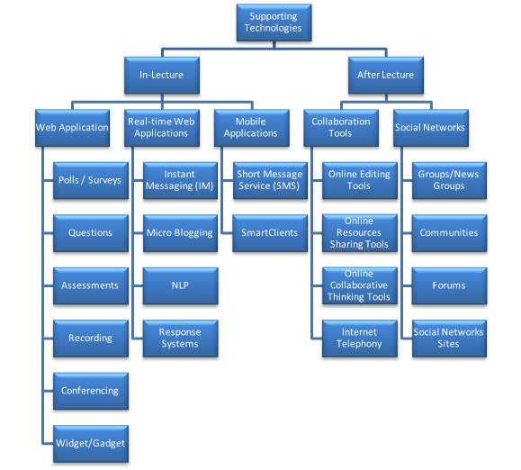
Figure 7: Taxonomy of Adaptive Lecture Innovative Supporting Technology

Table 5: Pedagogical Differences between In-Lecture and After-Lecture Similar Activities
 | In-Lecture | After-Lecture
Polls / Surveys | Informative | Summative
Interaction from Student to Instructor | Questions | Discussions
Interaction from Instructor to Student | Assessment for Learning | Assessment of Learning
Student Activity | Simple Tasks | Assignments

Same polls / surveys technology can be used in-lecture or after-lecture, however it must be clear for instructor that when it is used in-lecture, it is used in an informative way to get an idea on student’s following, understanding of the topics and their satisfaction with the learning flow, topics, content and any other instructor’s points of interest. However, when the same polls / surveys technology used after-lecture, it is used to give a summative feedback on the learning experience took place during the previous lecture/session. That means, informative knowledge can affect the lecture flow immediately while summative knowledge affects the next time activity. They both differ in nature and importance and can be achieved via same technology.

  - In-Lecture Web 2.0 Technologies
It is important to consider three lecture aspects: basic required functionalities, real-time data, and mobility. Basic required functionalities will be provided via the standard web application, due to high requirements that is still hard to provide over mobile devices. Real-time data plays an important role in monitoring students’ status, performance and satisfaction during lecture. Mobility shall be considered, facilitated and managed effectively. Mobile devices include mobile phones, smart phones, PDAs and any other handheld devices.

    - Web Application Technologies
Technically, web applications are applications that reside on a web server that is accessible over computer networks via a simple user client that is mainly web browser, and requires no user installations. From user experience, web applications are the most desirable user applications because they take the entire load off the user and provide all the required functionalities. Learning institutions have been using web applications in the learning process for a while. El-Ghareeb presents a list of open source, free and commercial LMSs [1]. Utilizing the following technologies within a pedagogical aspect yields wider effect on the learning process. Different Web application technologies that can be utilized include:

- Polls / Surveys: they are important in the learning process because they give instructors a suitable start point to begin at and an indicator on students’ performance during lecture. Instructors can use polls/surveys capabilities to check how many students have prepared for the lecture, have background on the topic to be discussed, interested in learning the current topic and many other criteria that affects the lecture path. Polls/surveys are easily integrated in the learning process from technical point of view, and they produce a high value in the learning process from the pedagogical aspect. They give the lecture a personalized theme that students can feel based on their feedback and responses.
- Questions: instructors might permit questions during lecture, or at the end of a lecture’s sections, or at the end of the lecture. This varies based on the instructor’s evaluation of the situation and the point s/he is discussing. Students can submit questions while the instructor is discussing the topic. When instructor feels it is appropriate to take questions, s/he reads submitted questions and starts answering them. Different implementations for questions can be presented in the lecture. One of the models includes presenting an (ask question) application for student to utilize during lecture. Students can submit questions online during lecture, and they immediately appear to instructor. It is instructor’s choice to answer this question immediately or later. Options like making questions viewable by all attendees, and/or identifying who asked the question are controlled by instructor. Another model might give students the capability to digitally raise hands, so they indicate they have a question without the capability for them to post their questions. A third model might make use of available teaching assistants and allows them to handle questions during the lecture, so questions don’t interrupt the lecture flow.
- Assessments: students’ progress measure in learning new topics is revealed by assessments. Different types, standards of quality, and utilization of assessments are available online. Assessment is used mainly to measure student’s progress and act as a starting point in enhancing the student’s learning experience. Different types of questions are made available via computers. IMS QTI standard “http://www.imsglobal.org/
question/” addresses 11 types of questions that can be presented and handled via computer technologies.
- Recording: The 2009 21st Century Campus Report (2009) stated that 61% of students identified the need for a video or voice recording mechanism for lectures where only 36% of instructors paid attention to this point [6]. Recording is an activity that produces a digital audio and/or video file that records all lecture activities, and gives students the ability to subscribe to and download via RSS feed to digital devices like an iPod or a desktop computer. A camera needs to be installed in the classroom to record class activities and upload them to the server.
- Conferencing: facilitates students’ attendance because they help students overcome challenges that might prevent them from attending sometimes. The 2009 21st Century Campus Report (2009) stated that 70% of students identified the need for distance learning capabilities to connect students in multiple locations, against only 40% of instructors who paid attention to this requirement [6]. Students can join the conference from their locations and it is equivalent to attending the lecture. Seamless integration might be required if instructors/learning institution utilize attendance tracking system.
- Widget / Gadget: they are a piece of reusable code that can be plugged into virtually any website. They have gained popularity because they give different capabilities for internet users like accessing different sites from the same web page. Users don’t have to leave current page to check for their social network sites, update their status, send emails, contact using messengers and do many other activities. One of the largest online Widget/Gadget galleries is the one presented and maintained by iGoogle “http://www.google.com/ig/directory”. Widget / Gadget as a technology that takes the implementation responsibility off the web site owners’ shoulder and still presents the capability to integrate different functionalities from different sites can be utilized as both concept and products in the learning portals.

    - Real-Time Web Application Technologies
Different technologies that enable users to communicate in real-time are available, however utilizing those technologies hasn’t been addressed in the optimum way. Further advanced research on available technologies, and enhancements to them is required. Real-time technologies that can be utilized in-lecture include:
- Micro Blogging: it is simply about sharing ideas, thoughts, activities, actions and updates in a small number of characters. Twitter is the most famous micro blog available, giving the capability to share whatever user wants to within 140 characters. Micro blogging is a real effective and touching technology. It is an easy way of sharing updates at real time. Students can easily access twitter from lecture and they are intimidating to do so already. It is surprising that twitter users tend to utilize news, so they can consume learning inside lecture as they consume news [4].
- Instant Messaging (IM): is a form of real-time communication between two or more people based on typed text. The text is conveyed via devices connected over a network such as the local institution network, or the internet. IM can be used mainly in the questions activity mentioned in the web application section and of course in many others. IM has taken new shape lately with the presence of converged networks, and the capability of multimedia networks. Voice over IP (VoIP) and multimedia enabled communication devices will revolutionize the way we utilize IM in the near future.
- Natural Language Processor (NLP): field of computer science and linguistics concerned with the interactions between computers and human natural languages. Natural language generation systems convert information from computer databases into readable human language. Natural language understanding systems convert samples of human language into more formal representations that can be altered and processed to generate useful information based on students’ submitted data. Further research on mining student’s real-time data submitted during lecture can be used in generating useful information about students’ satisfaction with lecture instead of relying on teaching assistants for summarizing and analyzing students’ feedback.
- Response Systems: allow users to respond with short answers immediately. Response system consists of two parts: the two ways True/False Clicker (TF Clicker) that students can use to answer questions immediately and an administration application that enables instructors to initiate questions and analyzes answers. Figure 8 presents a block diagram of TF Clicker. Students can respond to open-ended questions with alphanumeric answers by typing in text in a way similar to texting on mobile phone [16]. Renaissance Learning “http://www.renlearn.com” is one of the leading companies in providing Response Systems.
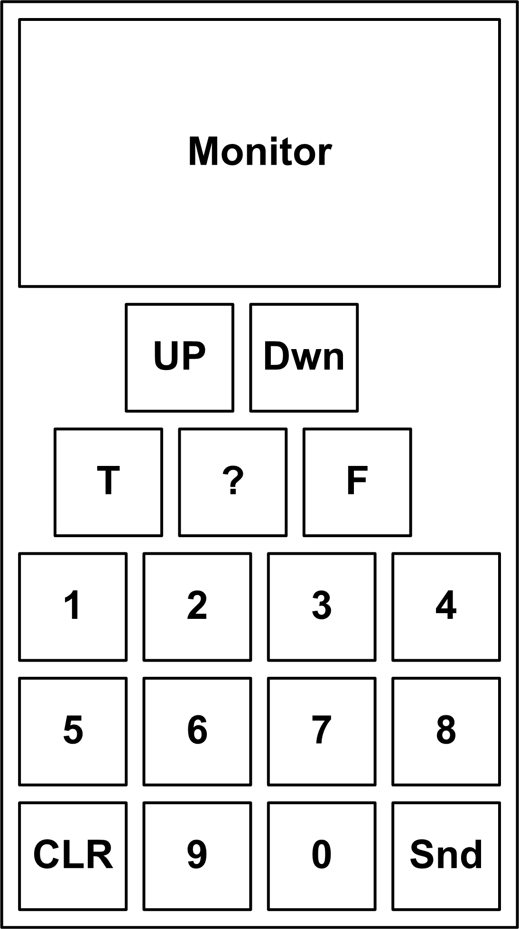
Figure 8: Block Diagram of TF Clicker

    - Mobile Applications
Utilizing mobile in learning is a wide area of research that is under evaluation, arguments and challenges. Mobile Learning (M-Learning) is an approach to e-Learning that simply utilizes mobile devices, yet it can also be viewed as a quiet different learning experience [17]. M-Learning has been used as a pre and/or post activity to other types of learning [18]. Mobile phones are widely popular and made available to almost everyone in the globe and it is only a matter of time till everyone holds a mobile phone. Users can achieve different activities from their mobile phones, like accessing emails, creating and editing documents, attaching and emailing them, updating calendars and many other activities. More than three-quarters (76%) of twitter users use the internet wirelessly either on a lap top with a wireless connection or via PDA, handheld or cell phone. In comparison, 57% of those who go online but do not use twitter and 59% of internet users as a whole connect to the internet wirelessly [4]. On the other hand, utilizing mobile phones is challenged and limited by mobile computing capabilities, small screen size, low screen resolution, short battery life and other challenges that are still limiting its wide utilization in different life aspects. Riad and El-Ghareeb presented a mobile utilization in the assessment activity as a form of utilizing mobile technologies in the learning process [19]. Mobile applications are enabled mainly via:
- Short Messaging Service (SMS): simplest way of communication using mobile phone. Sending SMS is an activity that includes editing the text message within a predefined number of characters, defining the recipient number and submitting the message. It is possible to force series of interactive SMS exchanges between student and LMS to achieve completion of a task or goal. Student will take part and complete the task [20]. SMS utilization in proposed Adaptive Lecture Model can fit within Polls / Surveys.
- Smart Clients: provide users with a rich and responsive user interface, the ability to work offline, and a way to take advantage of local hardware and software resources. In addition, they can be designed to run on a broad spectrum of client devices, including tablet PCs, and handheld mobile devices such as pocket PCs and smart phones. Smart clients give users access to information and remote services within a powerful and intuitive client environment and are an effective solution for flexible user-oriented applications and for increasing user productivity and satisfaction. Smart clients share some or all of the following characteristics: make use of local resources, make use of network resources, support occasionally connected users, provide intelligent installation and update and provide client device flexibility [21].

  - After Lecture Web 2.0 Technologies
After-lecture activities are very important in the learning process. These activities ensure that learning is moving from acquiring, gaining and recalling information to utilizing information in real-life situations and scenarios to become knowledge. Discussions, collaboration and socially utilizing information gained in lectures are important in all fields. From author’s point of view, collaboration tools and social networks are the most important today’s available online tools to integrate the informal learning in the learning process.

    - Collaboration Tools
Utilizing different collaboration technologies that exist will result in pedagogical effect. Educational collaboration information systems are responsible for facilitating collaboration technologies utilization within learning institutions. Collaboration technologies and tools include:

- Online Editing Tools: wikis, blogs, online documents editing, and mind mapping tools are some of the examples of collaboration tools that can be made available to students and to enrich learning process by motivating learning stakeholders to enrich learning.
  - Wiki: is simple collaborative editing software application which encourages users to be not only readers, but also content providers and editors [11]. Wikis have proven gained pedagogical and educational benefits. They encourage collaboration, and enhance writing, editing, discussion and critical skills.
  - Blog: are user journal entries in the form of text, images and links to web content such as websites or other blogs that have a variety of formats and might include the user expressing their opinion about a topic or documenting activities. Blogs are interactive in the sense that other users could provide comments on the information posted by the blog author. Educational applications of blogs include researching, tracking, interpreting and evaluating blogs for political commentary (multiple perspectives), cultural events, business or other news and for examining changes over time [10].
  - Mind Mapping Tools: they are important in putting different ideas into work, then start discussions in attempt to get the best out of them, and to relate and organize those ideas. They can be best used in problem solving sessions.
  - Online Documents Editing Tools: they provide different services that enable more than one to edit online documents and see changes immediately. Other complementary services include the ability to upload files from users’ desktops and save them online, editing online files anytime, anywhere without the need to install software other than the web browser, defining who can access those files, storing files securely online, importing and exporting different types of files, publishing those documents online when finished, so students can easily publish online documents that are accessible, enabling readers to leave comments and other features.
- Online Resources Sharing Tools: online workspaces and web drives for sharing files, maintaining versions, managing and arranging files within virtual folders and storing files online. Complimentary services like bulk files uploading, downloading, file sharing, mailing short links to available online files and other services are provided by multiple online resources sharing service providers.
  - Sky drives / Web drives: different web sites provide the service of uploading files and presenting short links for them to be downloaded later. Though this service has enabled files sharing online, obligations, restrictions and considerations about copyrights must be taken into consideration. The most suitable scenario for students is the Workspaces.
  - Workspaces: store online files to be shared between students and combines the functionality of online documents editing tools, so students need a web browser and Internet connection to access the online stored files, open and edit them via Web browser anytime and anywhere, so students can easily collaborate and share files in a productive manner.
- Online Collaborative Thinking Enabling Tools: they are important in sharing resources that students feel important to them in formalizing their ideas about some topics. Students might be working in groups in different topics in their graduation projects / lab projects and they might incorporate an online article that they feel the need for the rest to take a look. Social bookmarking services present this ability. Besides, online mind mapping tools are important in finalizing the overall ideas of the project they are working on, the document they are editing, and whatever collaborative activity they are attempting.
  - Social Bookmarking: allow users to store, describe, and share numerous web addresses with others. Users can explore bookmark collections of others by subscribing to their bookmark pages. If users are interested in a site, they could tag it using few words to help others find it easily. Educators could use social bookmarking to facilitate collaborative information discovery. They could create a social bookmarking page to save important pages about a topic. Students could also collaborate on group projects using bookmarking sites, sharing links and uploading resources discovered while educators could follow their students bookmark pages to gain insight on their research [10].
  - Mind Mapping Tools: they don’t edit the thing together. They share it for each other and receive comments on it. Generally, they don’t need so much collaboration in editing as it needs in discussion.
- Internet Telephony: it has witnessed a huge advancement in the late years as a result of the widespread of VoIP communication devices that utilize internet communication infrastructure in making phone calls. Students can communicate from PC to PC free of charge using Headsets and a free service provider. Also, they can communicate from PC to phone using headsets and a simple charge for the service provider. Students can use their emails as a “voice mail” and leave each other recorded voice files.

    - Social Networks
Social networks are a social structure of nodes that represent individuals (or organizations) and the relationships between them within a certain domain. Therefore, social networks are usually built based on the strength of relationships and trust between the members "nodes" [22]. People have been forming themselves into groups without the gratuitous nature of the internet or social software.

- Groups: they have been a widely spread method to communicate with people that sometimes don’t know each other in a productive way to share ideas and resources via sending emails to one email address that is the group email and the group service provider is responsible for delivering those emails to group subscribers based on their registration features. Registration features specify the details of mails to be delivered, delivery rate, preferred format and other features. Students read the emails, follow and contribute to the conversations they feel most important to them and ignore what they want. Though this is not the most perfect way of collaboration nowadays, groups have helped many students and professionals to communicate in an interactive way.
- Communities: different types of communities exist. The most related to interest is Community of Practice (CoP). A group of people in an online group with a common interest who share knowledge and expertise. Following a learning course, the participants form a CoP hosted by a leader to share material related to a shared experience or a course, get help on problems that arise and share best practices [23].
- Forums: online information sharing tool that allows students to submit questions and answer each other. A great tool in discussing updated topics and searching within history of answered questions and sharing experiences. Organizing topics under headers is an available option. Forums don’t need immediate responses, so they are an important asynchronous communication form.
- Social Network Sites: A social networking site is an online place where a user can create a profile and build a personal network that connects him or her to other users. In the past five years, such sites have rocketed from a niche activity into a phenomenon that engages tens of millions of internet users [24].

- Future of Attended Classes
Attended classes will witness changes as a result of web 2.0 technologies presence and the sake of integrating it into current learning process. For this change to achieve success, it needs to include the entire enterprise to define a broader prospective of University architecture. Enterprise in this case is the University, thus enterprise architecture and university architecture are used interchangeably. Enterprise architecture defines the enterprise’s different dimensions, connect between them and present a complete view for the enterprise environment to face the ubiquitous challenges. It has become accepted that there is a clear need for an architectural view of systems [25]. Enterprise architecture dimensions are: Business architecture, Software “Application” architecture, Information Technology (IT) architecture and Information architecture [26]. Enterprise architecture classes utilize each other and build over each other, and there are no clear distinctions between them. Figure 9 presents the enterprise architecture four dimensions and each dimension role.
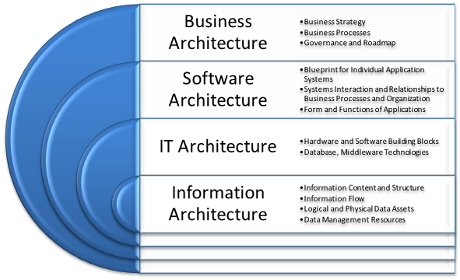
Figure 9: Enterprise Architecture Dimensions and Roles
Adopting web 2.0 technologies in current attended classes requires certain amount of enterprise agility that is provided by utilizing SOA within the four enterprise dimensions. Utilizing SOA provides educational institutions with both business and technical agility perspectives. Business agility means fast reaction to change and the ability to rapidly implement changes. Business agility needs to be holistic in scope [27]. Technical agility refers to the ability to quickly change the type and flow of information within an organization within enterprise. Enterprises should balance IT to become better positioned and more agile [28,29]. Services are the building Blocks of an agile enterprise [30].
Figure 10 presents a proposed IT architecture to support web 2.0 empowered attended classes. Educational institutions differentiate between different components required to support the learning process and are familiar with some technologies like UMIS and LMS, however they are newly acquiring real-time communication services in its new informal form. IT architecture includes the following servers list:
- Firewall: system’s entry point and responsible for providing security functions.
- Active Directory (LDAP): single log-in point for the entire system. Helps avoid the repeated log-in process between different applications and servers.
- Collaboration, Assessments, and Assignments: main components of the learning process that are maintained separately to provide greater flexibility and the ability to utilize different technologies.
- Students Data, Student Preferences, Learning Profiles: main asset of LMS that maintains students’ data to be utilized by different applications.
- Course Specifications and Instructors Data: data about instructors and courses are stored to enable automation of the communications between different components.
- Real-time and Web 2.0 Communication Server: responsible for providing communications between instructors and students, and students and each other. It also manages online lecture files, desktop, text sharing, other activities and web 2.0 technologies that will be utilized in the informal learning process and informal feedback.
- Analyzer and Report Generator: responsible for analyzing gathered data and generating reports that are used by instructor to identify the sequence of lecture activities, students’ learning profiles and preferences and feedback activities.
- Middleware: responsible for managing Quality of Service (QoS) and directing messages between different components of the systems.
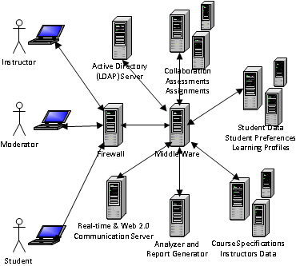
Figure 10: Proposed Adaptive Online Lecture Model IT Architecture
Cloud computing is an emerging IT technology that will be utilized in different innovative ways in learning institutions. Cloud computing is a large-scale distributed computing paradigm that is driven by economies of scale, in which a pool of abstracted, virtualized, dynamically-scalable, managed computing power, storage, platforms and services are delivered on demand to external customers over the internet [31]. Cloud computing is a distributed computing paradigm that focuses on providing a wide range of users with distributed access to virtualized hardware and/or software infrastructure over the Internet. Drivers for Cloud computing adoption include: scalability, elasticity, virtualization, cost, mobility and risk reduction [32].
- Future Research Directions
Future research directions in e-Learning include research in different technologies that shapes the presence of e-Learning 3.0. Technologies include: web 3D, semantic web, mining social networks, collaborative multimedia authoring, and NLP of real-time applications.

Web3D: the next major internet wave [33], Web3D will deliver an interactive, immersive experience much richer than the static, text-oriented or even interactive graphical interfaces of today’s web. In the new world of work that web3D will enable; people will be represented visually by avatars that can move in space, communicate with others and interact with objects and information. Yet Web3D won’t leave the old world behind. It will integrate with the Web technologies we use today. Workers will use Web3D to teach and learn, innovate collaboratively, communicate and network, interact with and present information and manage real-world systems.

Semantic Web in e-Learning: semantic web is a collection of standards, data structures and software that make the online experience more detailed, intelligent and in some cases, more intense. The goal of the Semantic web is to provide the capacity for computers to understand web content that exists on systems and servers across the internet, ultimately adding value to the content and opening rich new data, information, and knowledge frontiers. The potential of the Semantic web could actually revolutionize the learning experience and help it moving into web 3.0. Web 3.0 entitles better organized and more intelligent use of the knowledge available in the internet that will directly add potential to the learning process and create new learning environments.

Mining Social Networks: social networks include billions of terabytes of data, images, videos and many other file types that we need to analyze closely to come closer to newer generations, know how they utilize emerging technologies, how they think, feel and how they can utilize those technologies in a way that changes their lives to the better.

Collaborative Multimedia Authoring: recorded lectures can be enhanced, edited, updated and collaboratively worked on to present a rich multimedia repositories and learning content to students. An example of this collaboration is the one presented via We-Lcome to enable different students that can speak different languages from providing sub-titles in their languages to be added to the recorded lectures, so those lectures become available in different languages.

NLP of Real-time Applications Generated Data: imagine an NLP engine that is capable of automatically analyzing students’ feedback and providing both detailed and summary analytical reports about their perception of the lecture, and thoughts about the different activities conducted during that lecture till then. This feature can affect the flow of the lecture in a great manner. Such an engine will not enforce students to submit their updates specifically in a certain format, however it will work on their status updates on twitter, face book and whatever social networks and communication services they are using. This automated NLP is like an automatic analyzer of their thoughts and what goes in their minds about the lecture, so instructors can act fast and
quickly in response.

- Conclusion
The need for utilizing web 2.0 technologies came from the great demand from students to include technologies they utilize in different life aspects within learning and from the instructors’ desire to enhance the learning process and overcome challenges. Web 2.0 technologies can be used in delivering learning materials, supporting assignments, enhancing assessments experiences and many other learning activities. In this paper, taxonomy of different web 2.0 technologies was presented. This taxonomy highlights two main classes: in-lecture, and after-lecture. Web 2.0 technologies were mapped to each of those classes highlighting their powers and usage within learning institutions. Innovative real world examples of utilizing web 2.0 technologies in learning institutions were presented highlighting different advantages and challenges. Web 2.0 technologies utilization is a hot research point that has rich future research directions and touches the way learning institutions manage the learning process.

- References
- El-Ghareeb, H. A. (2009). E-Learning and Management Information Systems: Universities Need Both. eLearn Magazine, ACM, Retrieved October 28, 2009, from http://elearnmag.org/subpage.cfm?section=articles&article=96-1
- Pollock, J. T. (2009). Semantic Web for Dummies. Wiley Publishing Inc.
- Grosseck, G. (2009). To use or not to use web 2.0 in higher education? World Conference on Educational Sciences, - New Trends and Issues in Educational Sciences. Vol. 1, Issue 1, El-Sevier, Nicosia, North Cyprus.
- Lenhart, A., & Fox S. (2009). Twitter and Status Updating. Pew Internet & American Life Project. Retrieved November 11, 2009, from http://www.pewinternet.org/Reports/2009/Twitter-and-status-updating/Part-1/Section-4.aspx?r=1
- Fox, S., Zickuhr, K., & Smith, A. (2009). Twitter and Status Updating, Fall 2009. Pew Internet & American Life Project. Retrieved November 11, 2009, from http://www.pewinternet.org/Reports/2009/17-Twitter-and-Status-Updating-Fall-2009.aspx
- The 2009 21-st Century Campus Report, (2009). CDW-G. Retrieved November 12, 2009, from http://webobjects.cdw.com/webobjects/media/pdf/Newsroom/CDWG-21st-Century-Campus-1009.pdf
- Alexander, B., & Levine, A. (2008). Web 2.0 Storytelling. Emergence of a New Genre. In EduCAUSE Review. Vol. 43 / no. 6. Nov./Dec. 2008. 40-56. Retrieved November 9, 2009, from http://net.educause.edu/ir/library/pdf/ERM0865.pdf
- Downes, S. (2008). Ten web 2.0 things you can do in ten minutes to be a more successful e-learning professional, eLearn Magazine.
- Agee, A. S., Yang, C., & the 2009 EDUCAUSE Current Issues Committee (2009). Top – Ten IT Issues. EDUCAUSE Review. Vol. 44, No. 4, July/August 2009. Retrieved November 11, 2009, from http://www.educause.edu/ir/library/pdf/erm0943.pdf
- Ajjan, H., Hartshorne, R. (2008). Investigating faculty decisions to adopt Web 2.0 technologies: Theory and empirical tests. The Internet and Higher Education. Vol. 11, Issue 2. El-Sevier.
- Küfi, E. Ö, & Özgür, B. (2009). Web 2.0 in learning English: the student perspective. World Conference on Educational Sciences - New Trends and Issues in Educational Sciences, Vol. 1, Issue 1. Nicosia, North Cyprus.
- Fischman, J. (2009). Continuing Education and Social Networking Combine to Attract Students. College of Liberal and Professional Studies, Penn LPS. Retrieved March 10, 2010, from http://www.sas.upenn.edu/lps/news_110409 .
- SUNGARD Higher Education Press. (2009). SunGard Higher Education, The New York Times Company and Epsilen Collaborate to Support Advances in e-Learning. Retrieved March 10, 2010, from http://www.sungardhe.com/about/news/PressReleases/
Article.aspx?id=8945&LangType=1033
- Schaffhauser, D.. (2009). iParadigms Updates Peer Review App. Campus Technology. Retreived November 12, 2009, from http://campustechnology.com/articles/2009/11/04/iparadigms-updates-peer-review-app.aspx
- McCrea, B. (2009). Purdu U Brings Social Networking to the Classroom: Hotseat allows students to text in class. Campus Technology. Retrieved on November 29, 2009, from http://campustechnology.com/Articles/2009/11/18/Purdue-U-Brings-Social-Networking-to-the-Classroom.aspx?Page=1
- Nagel, D. (2009). 2Know Classroom Response System Gets Short Answer Feature. Campus Technology. Retrieved on November 12, 2009, from http://campustechnology.com/articles/2009/09/10/2know-classroom-response-system-gets-short-answer-feature.aspx
- Hulme, A. K. & John T. (2005). Mobile Learning: A Handbook for Educators and Trainers (Open & Flexible Learning). Routledge Falmer.
- Rogers, Y., Price, S., Fitzpatrick, G., Fleck, R., Harris, E., Smith, H., Randell, C., Muller, H., O'Malley, C., Stanton, D., Thompson, M., & Weal, M. (2004). Ambient Wood: Designing New Forms of Digital Augmentation for Learning Outdoors. IDC ACM Maryland, USA, ACM.
- Riad, A., & El-Ghareeb, H. (2008). A Service Oriented Architecture to Integrate Mobile Assessment in Learning Management Systems. Turkish Online Journal of Distance Education (TOJDE), Vol. 9, No.2, Article 12.
- Stone A., Briggs J., & Smith C. (2002). SMS and Interactivity – Some Results from the Field, and its Implications on Effective Uses of Mobile Technologies in Education. In IEEE International Workshop on Wireless and Mobile Technologies in Education (WMTE’02).
- Hill, D., Webster, B., Jezierski, E., Vasireddy, S., Al-Sabt, M., Wastell, B., Rasmusson, J., Gale, P., & Slater, P. (2004). Smart Client Architecture and Design Guide. Microsoft Patterns and Practices, Microsoft Corporation. Retrieved December 19, 2009, from http://msdn.microsoft.com/en-us/library/ms998506.aspx
- Liccardi, I., Ounnas, A., Pau, R., Massey, E., Kinnunen, P., Lewthwaite, S., Midy, M., & Sarkar, C. (2007). The role of social networks in students' learning experiences. In Annual Joint Conference Integrating Technology into Computer Science Education, Working group reports on ITiCSE on Innovation and technology in computer science education. ACM, NY, USA.
- Schooley, C., Charron, C., Driver, E., Li, C., & Fossner, L. (2006). Social Computing Reshapes eLearning: Informal Learning Becomes a Component in Blending Learning and Work. Forrester Research, Inc.
- Lenhart, A., & Maden, M. (2007). Social Networking Web Sites and Teens. Pew Internet & American Life Project. Retrieved November 12, 2009, from http://www.pewinternet.org/Reports/2007/Social-Networking-Websites-and-Teens.aspx
- Macaulay, A. (2004). Enterprise Architecture Design and the Integrated Architecture Framework. Microsoft Architects Journal, Vol. 1, pp. 4-9.
- Albin, S. T. (2003). The Art of Software Architecture: Design Methods and Techniques. John Wiley & Sons, 2003.
- Evans, N. (2001). Business Agility: Strategies for Gaining Competitive Advantage Through Mobile Business Solutions. Prentice Hall.
- Baskerville, R. (2005). Business Agility and Information Technology Diffusion. Springer.
- Leidner, D., R. Beatty, R., & Mackay, J. (2003). How CIOs Manage IT During Economic Decline: Surviving and Thriving Amid Uncertainty. MIS Quarterly Executive,Vol. 2.
- Pal, N., & D. Pantaleo, D. (2005). The Agile Enterprise: Reinventing Your Organization for Success in an on Demand World. Springer.
- Foster, I., Zhau, Y., Ioan, R., & Lu, S. (2008). Cloud Computing and Grid Computing: 360-Degree Compared. Grid Computing Environments Workshop. Cornell University Library. Retrieved December 25, 2009, from http://arxiv.org/ftp/arxiv/papers/0901/0901.0131.pdf
- Lewis, G. A. (2009). Cloud Computing. SEI [Webinar]. Carnegie Mellon University
- Driver, E., Moore, C., Jackson, P, Keitt, T., Schooley, C., & Barnett, J. (2008). Web3D: The Next Major Internet Wave For Information & Knowledge Management Professionals. Forrester Research, Inc.

